*NAME:=Purva Tagde*

*PRN:=23070521111*

**Introduction to PL/SQL *Conditions***

In PL/SQL, conditions allow decision-making in programs. The two main types of conditional statements are: **IF-THEN**  **IF-THEN-ELSE**

**IF-THEN-ELSIF-ELSE**

**CASE Statement**

# IF-THEN Statement

Executes a block of code if the condition is TRUE.

## Example: Check if a number is positive

SET SERVEROUTPUT ON; DECLARE num NUMBER := 10;

BEGIN

IF num > 0 THEN

DBMS_OUTPUT.PUT_LINE('The number is positive.');

END IF;

END; /

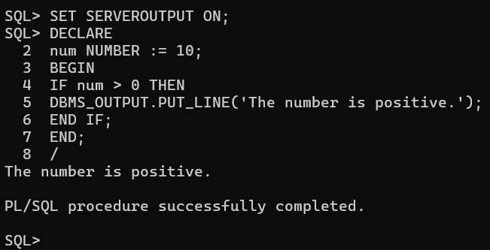

# IF-THEN-ELSE Statement

Executes one block if the condition is TRUE, otherwise executes another block.

## Example: Check if a number is even or odd

SET SERVEROUTPUT ON;

DECLARE num NUMBER := 7;

BEGIN

IF MOD(num, 2) = 0 THEN

DBMS_OUTPUT.PUT_LINE('Even number');

ELSE

DBMS_OUTPUT.PUT_LINE('Odd number');

END IF;

END; /

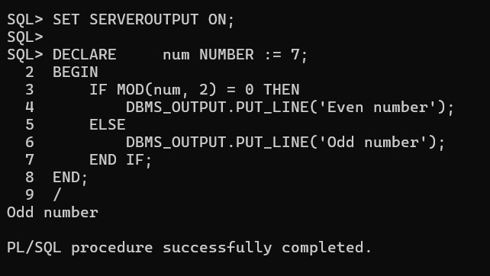

# IF-THEN-ELSIF-ELSE Statement

Check multiple conditions one by one.

## Example: Check if a number is positive, negative, or zero

SET SERVEROUTPUT ON; DECLARE

num NUMBER := -5; BEGIN

IF num > 0 THEN

DBMS_OUTPUT.PUT_LINE('Positive number');

ELSIF num < 0 THEN

DBMS_OUTPUT.PUT_LINE('Negative number');

ELSE

DBMS_OUTPUT.PUT_LINE('Zero');

END IF;

END; /

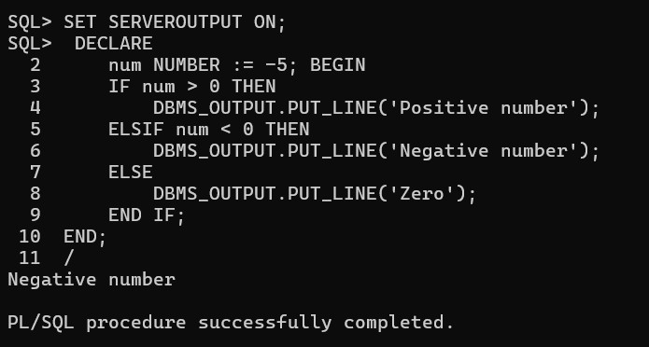

# CASE Statement

The CASE statement is used to handle multiple conditions more efficiently.

## Example: Grade Calculation Using CASE

SET SERVEROUTPUT ON; DECLARE

marks NUMBER := 85;

grade VARCHAR2(10); BEGIN

grade := CASE

WHEN marks >= 90 THEN 'A'

WHEN marks >= 80 THEN 'B'

WHEN marks >= 70 THEN 'C'

ELSE 'Fail'

END;

DBMS_OUTPUT.PUT_LINE('Grade: ' || grade);

END; /

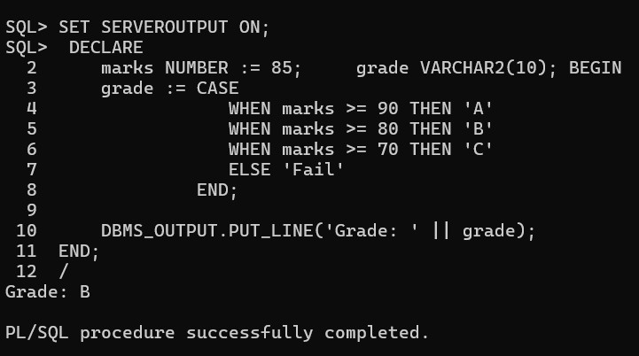

BBB B B

# Simple Tasks for Practice

1. Write a PL/SQL program to check whether a number is **divisible by 5**.

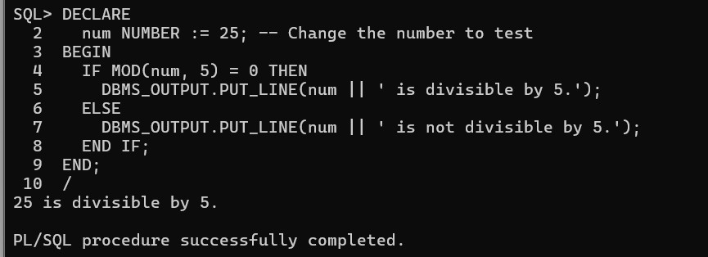

1. Modify the **grade program** to include more conditions (e.g., 60-70 for **D**, below 60 for

**F**).

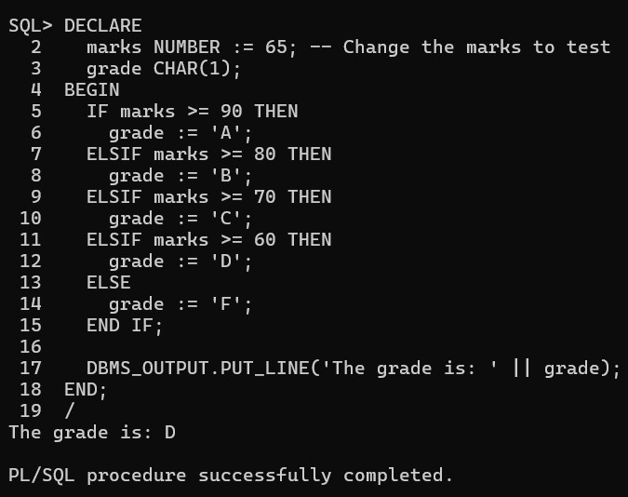

1. Write a **CASE statement** to display the day of the week based on a number input (1 = Monday, 2 = Tuesday, etc.).

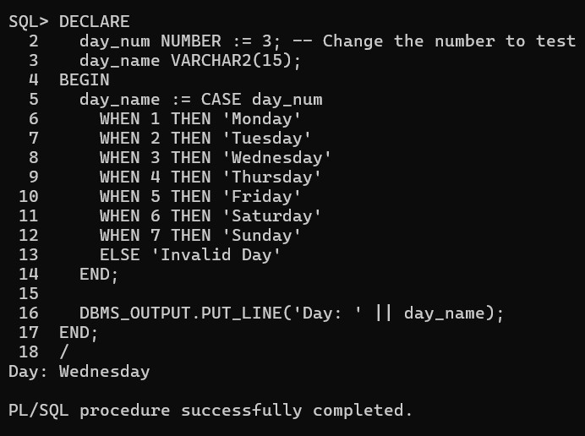

1. Create a program that **checks the largest of three numbers** using IF-THEN-ELSIF.

